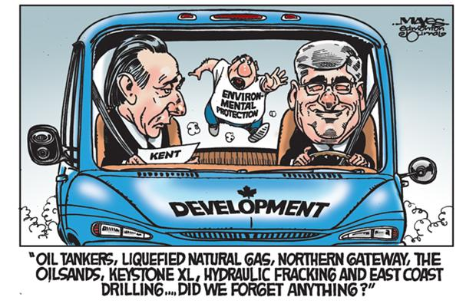
From The Edmonton Journal . February 2013.

What do you think is the cartoonist’s message? In what ways do you agree or disagree? What is the significance of a government’s action/reaction/inaction when it comes to the natural environment?

